Lesson 3 Homework | LT 1.3 | 2, 5, 13-19 odd, 24, 33, 43  (write all formulas for #17, 19, 33, & 43)  (simplify all square roots in #33&43. No decimals!)

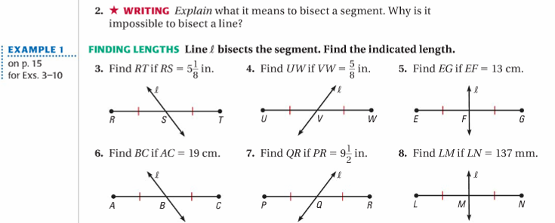
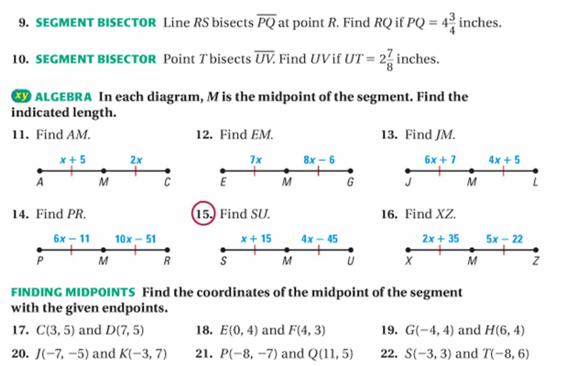

Lesson 3 Homework | LT 1.3 | 2, 5, 13-19 odd, 24, 33, 43  (write all formulas for #17, 19, 33, & 43)  (simplify all square roots in #33&43. No decimals!)
